## Questions about Oregon domoic acid monitoring data

### Q1. Species

I would like to assign a scientific name to each of the species common names included in the “PRODUCT” description to disambiguate species identity. The table below summarizes my decisions about how to group and harmonize common names used in the data.

1. Do “Crab”, “Bay crab”, and “Ocean crab” all refer to “Dungeness crab”? Yes.
2. Are all the softshell/thinshell clam/mussel species the same? We have had inspectors interchange softshell and thinshell. I don’t know about clam/mussel which should not be paired.
3. Are “California mussels” and “California blue mussels” the same? They should all be California mussels only.
4. Does “mini razors” refer to “razor clams”? I’m guessing. That is a weird one. Maybe they were just small razor clams??
5. Are “Gaper clams” and “Oregon gaper clams” the same? Yes.
6. Are “Asian clams”, “Asian varnish clams”, “purple varnish clams” and “varnish clams” the same? Yes.
7. Are “bay clams”, “clams”, “mussels”, “oysters”, and “tsunami debris mussels” species-specific or do they represent a group of species? Bay clams will be unspecific and could be any species of clam other than a razor clam. In other words, a clam found not on the beach itself. Usually this will be a gaper or potentially a cockle clam. Mussels will be California mussels. Oysters will always be Pacific oysters. Tsunami debris mussels are going to be something taken off the piece of dock that floated over from Fukushima…basically a one off sample I’m guessing.

**Table 1.** Harmonizing identity of species analyzed in the OR biotoxin monitoring program.

|  |  |  |
| --- | --- | --- |
| **Common name** | **Scientific name** | **Common names in original data** |
| Cockle clam | *Clinocardium nuttallii* | Cockle clams, Cockles |
| Native littleneck clam | *Leukoma staminea* | Littleneck clams |
| Dungeness crab | *Metacarcinus magister* | Bay crab, Crab, Dungeness crab, Ocean crab |
| Eastern softshell clam | *Mya arenaria* | Eastern softshell clams, Eastern thinshell clams, Eastern thinshell mussels, Softshell clams, Thinshell clams |
| California mussel | *Mytilus californianus* | California blue mussels, California mussels |
| Bay mussel | *Mytilus edulis* | Bay mussels |
| Purple varnish clam | *Nuttallia obscurata* | Asian clams, Asian varnish clams, Purple varnish clams, Varnish clams |
| Butter clam | *Saxidomus gigantea* | Butter mussels |
| Razor clam | *Siliqua patula* | Mini razors, Razor clams |
| Gaper clam | *Tresus capax* | Gaper clams, Oregon gaper clams |
| Bay clam spp. | NA | Bay clams |
| Clam spp. | NA | Clams |
| Mussel spp. | NA | Mussels |
| Mussel spp. (tsunami debris) | NA | Tsunami debris mussels |
| Oyster spp. | NA | Oysters |
| Unknown | NA | Unknown |

### Q2. Quantities

There are 689 samples that have no value provided in the “QUANTITY” column but have information included in the “QUANTITY COMMENT” column. Can I use the quantity comments to fill the missing quantity values. If so, how should I interpret the comments, especially when they provide two different numbers? All examples are provided below.

< 1.0 ppm MRl = 1.0 ppm

< 1.0 ppm MRL = 1.0 ppm

< 1.0 ppm MRL=1.0 ppm

< 5.5 ppm PL=5.5 ppm

<1.0 ppm MRL = 1.0 ppm

<1.0 ppm MRL=1.0

<1.0 ppm MRL=1.0 ppm

<2.0 ppm MRL=2.0 ppm

<5.5 ppm PL=5.5 ppm

1.0 ppm MRL=1.0 ppm

1.1 ppm MRL=1.0 ppm

1.2 ppm MRL=1.0 ppm

1.3 ppm MRL=1.0 ppm

1.4 ppm MRL=1.0 ppm

1.5 ppm MRL = 1.0 ppm

1.5 ppm MRL=1.0 ppm

1.6 ppm MRL=1.0 ppm

1.7 ppm MRL=1.0 ppm

12 ppm MRL=1.0 ppm

120 ppm MRL=1.0 ppm

14 ppm MRL=1.0 ppm

18 ppm MRL=1.0 ppm

2.0 ppm MRL=1.0 ppm

2.1 ppm MRL=1.0 ppm

2.3 ppm MRL=1.0 ppm

2.5 ppm MRL=1.0 ppm

2.6 ppm MRL=1.0 ppm

2.8 ppm MRL=1.0 ppm

21 ppm MRL=1.0 ppm

23 ppm MRL=1.0 ppm

27 ppm MRL=1.0 ppm

3.0 ppm MRL=1.0 ppm

3.2 ppm MRL = 1.0 ppm

3.2 ppm MRL=1.0 ppm

3.3 ppm MRL=1.0 ppm

3.7 ppm MRL=1.0 ppm

3.8 ppm MRL=1.0 ppm

3.9 ppm MRL=1.0 ppm

33 ppm MRL=1.0 ppm

33. ppm MRL = 1.0 ppm

37 ppm MRL=1.0 ppm

4.0 ppm MRL=1.0 ppm

4.4 ppm MRL=1.0 ppm

4.5 ppm MRL=1.0 ppm

4.6 ppm MRL=1.0 ppm

4.8 ppm MRL=1.0 ppm

4.9 ppm MRL=1.0 ppm

45 ppm MRL=1.0 ppm

47 ppm MRL=1.0 ppm

49 ppm MRL=1.0 ppm

5.0 ppm MRL=1.0 ppm

5.2 ppm MRL = 1.0 ppm

5.6 ppm MRL=1.0 ppm

55 ppm MRL=1.0 ppm

59 ppm MRL=1.0 ppm

6.0 ppm MRL=1.0 ppm

6.7 ppm MRL=1.0 ppm

6.8 ppm MRL=1.0 ppm

6.9 ppm MRL=1.0 ppm

62 ppm MRL=1.0 ppm

7.1 ppm MRL=1.0 ppm

7.9 ppm MRL=1.0 ppm

88 ppm MRL = 1.0 ppm

9.1 ppm MRL=1.0 ppm

9.4 ppm MRL=1.0 ppm

97. ppm MRL = 1.0 ppm

No testing oer J Dowell

No testing per J Dowell

### 

### Q3. Crab viscera - General History

There are 114 samples with “Crab Viscera- General History” provided as the “LOCATION” of sampling. The product names for these samples include a port name. How should I interpret these? Are these samples collected from crabs landed in that port but we don’t know where in the ocean the crabs were captured? Totally fine, I’m just curious!

### Q4. 2012-2014 Dungeness crab data

There are no Dungeness crab samples in 2012-13 and 2013-14 seasons and limited samples for the 2011-12 and 2014-15 and I wanted to make sure this isn’t an error.

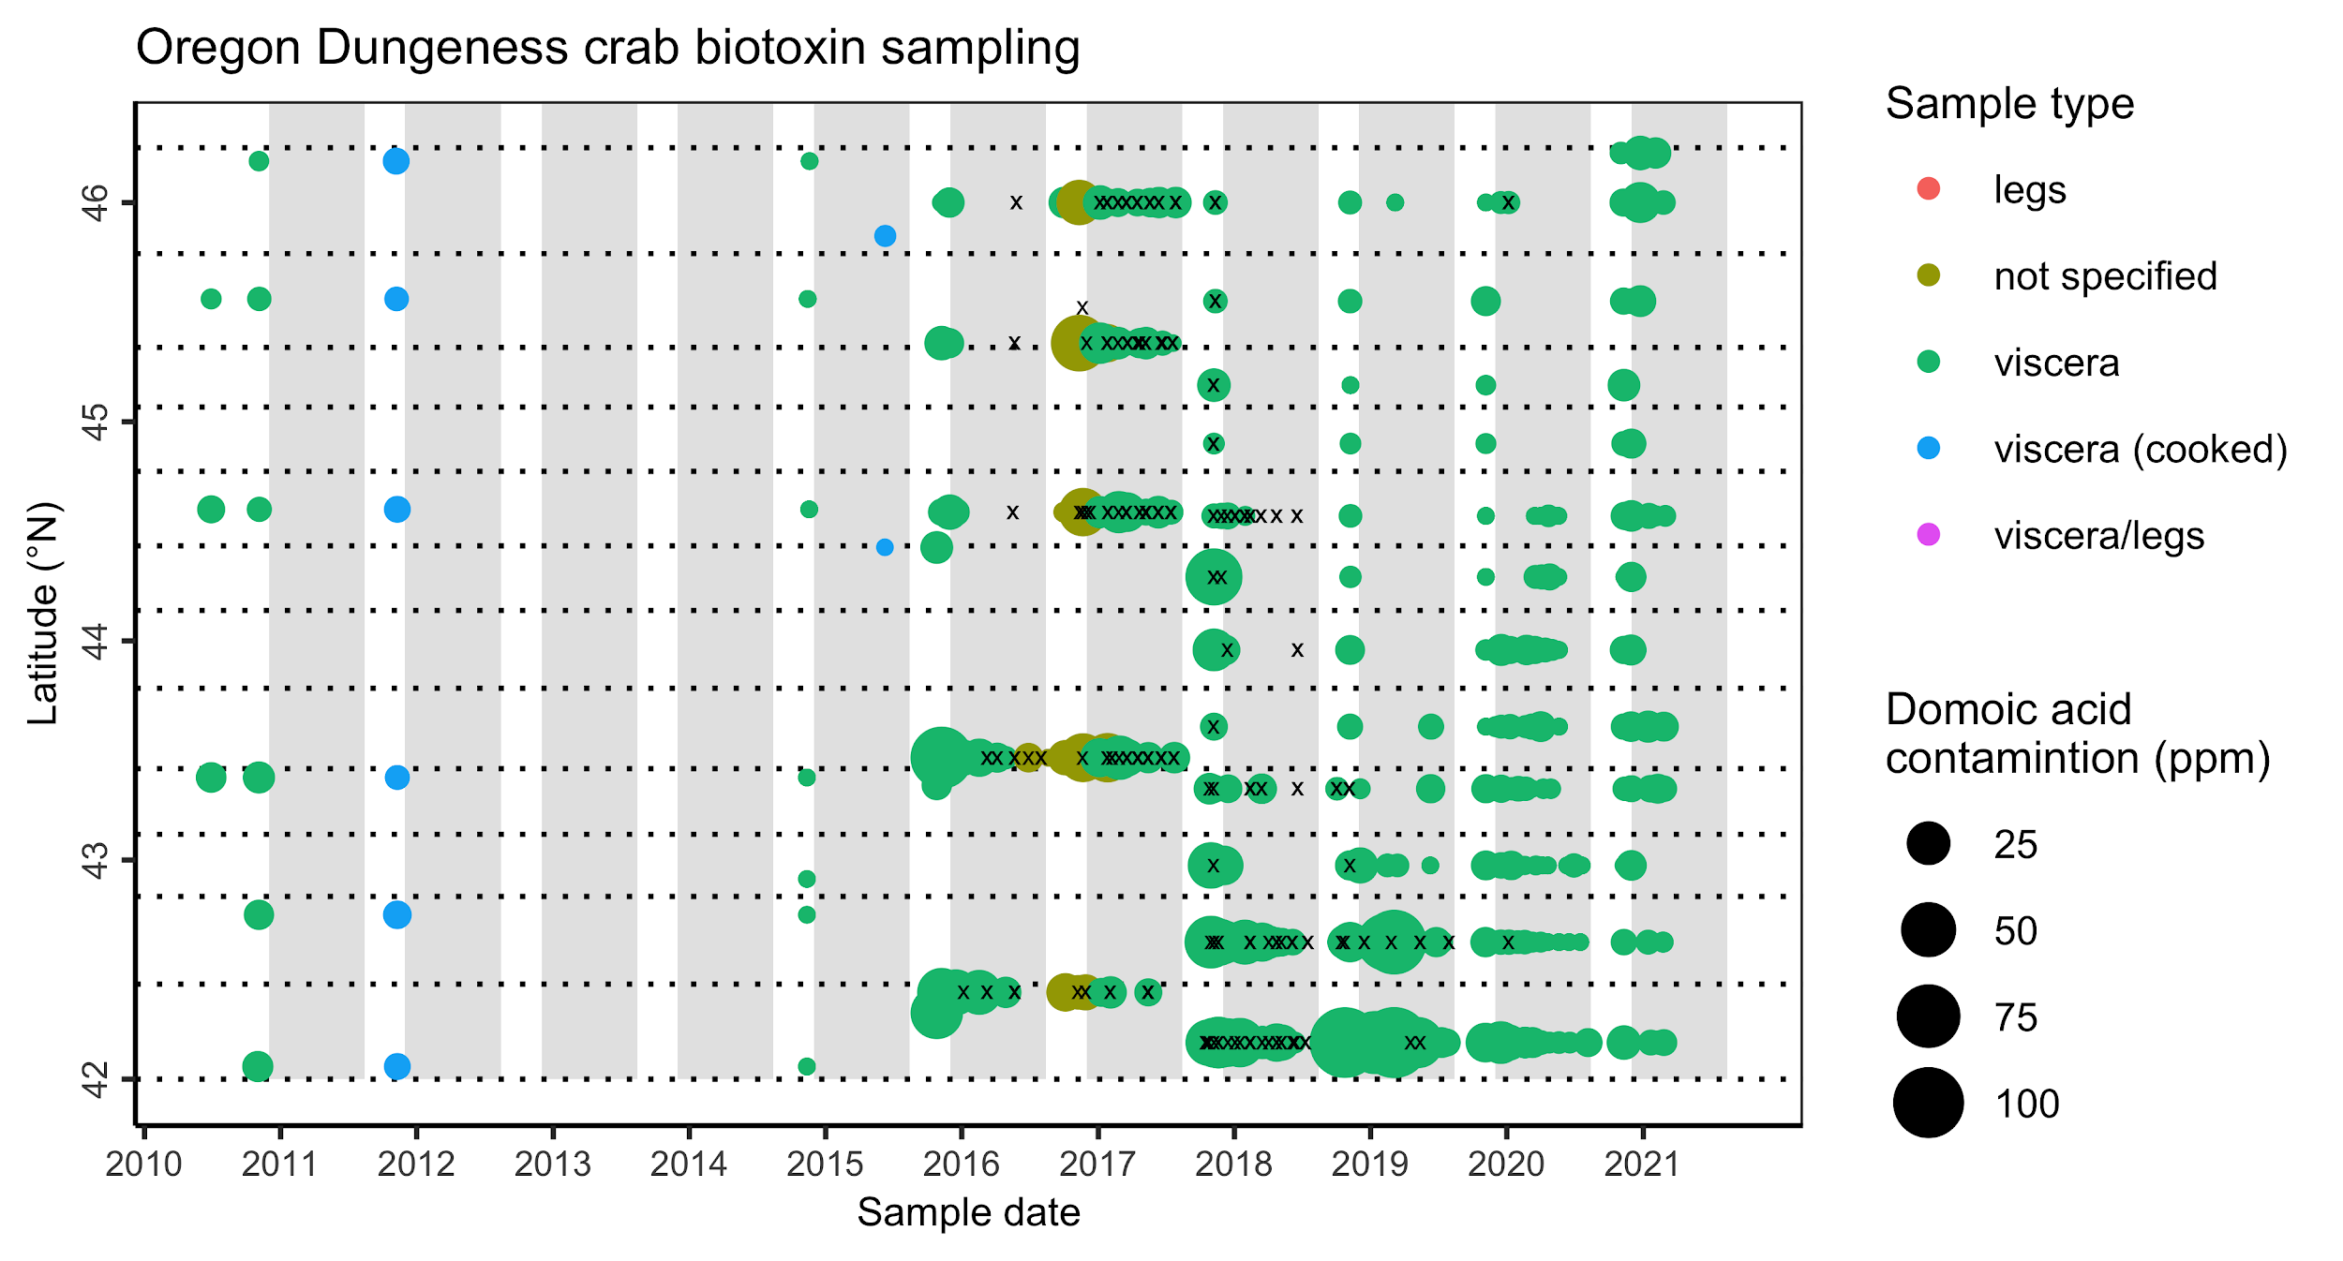

**Figure 1.** Domoic acid contamination (ppm) in Dungeness crab from 2010-present. The dotted lines indicate the biotoxin management zones established in 2017. The grey rectangles indicate the commercial Dungeness crab fishing season (Dec 1 - Aug 14). The small black x’s indicate samples without reported quantities.